

MAHARASHTRA STATE BOARD OF TECHNICAL EDUCATION, MUMBAI
A Project Report on
Civic Issue Reporting and Solution System
Submitted as a partial fulfillment for the award of
Diploma in Computer Engineering

Submitted by

Khairnar Rohit Dilip

Patil Kalyani Mahesh

Shirsath Darshan Atul

Sonawane Rohan Pramod


A Project Report on

Civic Issue Reporting and Solution System

Submitted in partial fulfillment for the award of Diploma in Computer Engineering

By

Khairnar Rohit Dilip 24610960305

Patil Kalyani Mahesh 24610960311

Shirsath Darshan Atul 24610960313

Sonawane Rohan Pramod 24610960315

Guided by

Mr.C.P Bhamare




MAHARASHTRA STATE BOARD OF TECHNICAL EDUCATION, MUMBAI
S.S.V.P.S's Bapusaheb Shivajirao Deore Polytechnic, Dhule
DEPARTMET OF COMPUTER ENGINEERING
CERTIFICATE
This is to certify that,

Sr.  No. | Roll No. | Name | Enrollment Number | Exam Seat number
1 | 115 | Khairnar Rohit Dilip | 24610960305 | 405678
2 | 120 | Patil Kalyani Mahesh | 24610960311 | 405683
3 | 122 | Shirsath Darshan Atul | 24610960313 | 405685
4 | 123 | Sonawane Rohan Pramod | 24610960315 | 405686

from S.S.V.P.S’s B. S .Deore Polytechnic, Dhule have completed Capstone Project of final year having title “Civic Issue Reporting and Solution System ” during the academic year 2025-2026. The project is completed in a group consisting of four persons under the guidance of the Faculty Guide.

Date : |  | Place: Dhule
Signature: |  | Signature:
Name : | Mr. C. P Bhamare  Guide | Name : Mr. N. D Patil  H.O.D.
Signature: |  | Signature:
Name : | External | Name : Prof S.A Hire  Principal

Acknowledgment

We would like to express our sincerest gratitude to all people who have contribute towards our project. We would like to extent our heartiest thanks to the Head of Computer Department Mr. N. D. Patel and our mentor Mr. C.P Bhamare for their important guidance, help and advice which was really important for our overall capstone project.
Also we would like to extent our thanks to all faculty of our department and all our colleagues who helped us in completion of the project.

Khairnar Rohit Dilip

Patil Kalyani Mahesh

Shirsath Darshan Atul

Sonawane Rohan Pramod

Abstract

In many cities, citizens face daily problems such as damaged roads, improper garbage collection, water leakage, and streetlight failure. These problems are often not reported properly due to lack of a common platform, manual complaint processes, and local authorities. As a result, issues remain unresolved for a long time.
To overcome these problems, the problem reporting & solution facility is proposed as a web-based system that allows citizens to report issues online easily. Users can submit complaints with details such as problem description, category, location, and image. Each complaint is assigned a unique complaint ID, which helps users track the status of their complaint.
The system provides various facilities such as online problem reporting, complaint tracking, status updates, notifications, and feedback submission. Admin and concerned departments can view complaints, assign them to appropriate authorities, update their status, and provide solutions.This system ensures transparency, faster problem resolution, and improved communication between citizens and authorities, leading to better local governance and improved quality of life.

Content Page

Chapter  Number | Title | Page Number
 | List of Figures | i
 | List of Tables | iii
1 | Introduction or Background of Industry | 1-2
2 | Literature Survey and Specification | 3-5
2.1 | Study of existing system / Review of Research Paper | 6
2.2 | Limitations of Existing System / Problems Discussed in Research Papers | 7
2.3 | Problem Identification / Need of a System | 8
2.4 | Problem Definition | 8
2.5 | Specification | 8
3 | Scope of Project | 9-11
4 | Methodology with Action Plan | 12
4.1 | User Requirement | 13
4.2 | Block Diagram Of System | 14
4.3 | Action Plan | 15
4.4 | Technology Use to Develop Project | 16
5 | Details of Design, Working and Progress | 17-22
6 | Result and Applications | 23-31
7 | Testing | 32-49
8 | Conclusion and Future Scope | 50
9 | Reference and Bibliography | 51

List of Figures

Sr. No. | Title of Figure | Page No.
4.1 | Block Diagram of Civic Issue Reporting and Solution System | 16
5.1 | Flow Diagram of Civic Issue Reporting and Solution System | 17
5.2 | User Module Flow | 19
5.3 | Administrator Module Flow | 20
5.4 | ER Diagram of Civic Issue Reporting and Solution System | 21
6.1 | Home Page of Civic Issue Reporting and Solution System | 22
6.2 | Registration form for Citizen | 27
6.3 | Login Page for Admin User | 29
6.4 | Login Page for User | 29
6.5 | Admin Home Page | 31
6.6 | View Newly Registered Student – Admin | 32
6.7 | All student list – Admin | 32
6.8 | Group management – Admin | 33
6.9 | Mentor Assignment – Admin | 33
6.10 | Add Project Details – Admin | 34
6.11 | Mentor Management – Admin | 34
6.12 | Add Timeline Activity - Admin | 35
6.13 | Add Weekly Date To Activity Planned – Admin | 35
6.14 | View Timeline [Semester 5/ 6] – Admin | 36

Sr. No. | Title of Figure | Page No
6.15 | Monitor Progress [Semester 5/6] – Admin | 36
6.16 | Home Page – Mentor | 37
6.17 | Timeline Management – Mentor | 37
6.18 | View Weekly Diary – Mentor | 39
6.19 | Approved/Not Approved Weekly Diary – Mentor | 39
6.20 | Add Task – Mentor | 40
6.21 | View Task – Mentor | 40
6.22 | Approval Of Task – Mentor | 41
6.23 | Monitor Progress - Mentor | 41
6.24 | Home Page - Student | 42
6.25 | Timeline Management - Student | 42
6.26 | Add Weekly Diary - Student | 43
6.27 | View Submitted Diary – Student | 44
6.28 | Update Diary - Student | 44
6.29 | Task Management – Student | 45
6.30 | Submit Task - Student | 45

List of Tables

Sr. No. | Title of Table | Page No.
1 | Study of Existing Civic Issue Reporting and Solution System | 6
2 | Database Table Description | 17
3 | Student Registration Form Validations | 27
4 | Mentor Registration Form Validations | 28

CHAPTER 1

INTRODUCTION AND BACKGROUND OF INDUSTRY

Introduction:

A Civic Issue Reporting and Solution System is a web-based system developed to provide an efficient way for users to report problems and receive solutions in a structured manner. In many situations, people face difficulties in communicating their issues to the concerned authorities or finding the right solution quickly. This website helps to overcome these challenges by offering a centralized platform for problem submission and resolution.
The system allows users to register, log in, and submit their problems under different categories such as technical issues, public complaints, or general queries. Once a problem is submitted, it can be reviewed by administrators who provide appropriate solutions. Users can also track the progress of their complaints and get updates in real time.
The platform maintains a database of previously solved problems, which helps other users find answers without submitting the same issue again. This improves efficiency and saves time. The website also encourages user interaction through comments or discussions, making it more collaborative.

Background of The Industry:
The rise of digital technologies has transformed the way individuals and organizations report problems and seek solutions. Traditionally, problem reporting in industries, public services, and educational institutions was handled through manual processes such as letters, emails, or in-person complaints. This approach often led to delays, miscommunication, and inefficient problem resolution. ns to maintain proper records of these leave requests to ensure smooth academic operations.
With the growth of the IT and software service industry, online platforms for problem reporting and solution management have become essential. Many industries—including government services, education, healthcare, and IT support—require systematic methods to handle large volumes of user complaints and queries efficiently. These platforms not only streamline the reporting process but also provide a trackable, transparent, and accountable workflow for resolving issues.
The system helps in developing the following advantages in institutions:
a) Efficient Problem Reporting Users can submit problems quickly without manual paperwork.
b) Timely Solutions Problems are addressed faster due to systematic tracking and management.
c) Encourages collaborative problem-solving among users and authorities.
d) Faster responses and clear communication enhance overall satisfaction.

CHAPTER 2
LITERATURE SURVEY AND SPECIFICATION

Study of Existing System / Review of Research Paper:

The study of existing systems and research papers is important to understand how civic issues are currently reported and managed. Many systems have been developed to help citizens report problems related to public services such as road damage, water supply, waste management, and street lighting.

Existing civic issue reporting systems mainly allow users to submit complaints, track their status, and receive updates from authorities. These systems are widely used by government bodies and municipal corporations to improve communication with citizens.

Studying these systems helps in identifying gaps and designing a more efficient and transparent Civic Issue Reporting and Solution System.

Study of exiting project management application

Table 1 Study of existing Civic Issue Reporting and Solution System

Sr No. | Application | Description
1. | CPGRAMS | Allows citizens to submit complaints, track status, and receive acknowledgments. Focuses on complaint monitoring but does not provide automated solutions.
2. | Swachhata App | Used for reporting cleanliness-related issues like garbage. Allows image upload and tracking but limited to specific categories..

Limitations of Existing System / Problems Discussed in Research papers :
The existing system used for reporting civic issues is mostly manual or partially digital, where citizens have to visit government offices or use basic complaint systems. Although these methods have been used for many years, they have several limitations that affect efficiency, transparency, and timely problem resolution. As the population and number of complaints increase, these limitations become more serious and create difficulties for both citizens and authorities.
One of the major problems with the existing system is that complaints are not properly tracked or managed. In many cases, once a complaint is submitted, the user does not receive proper updates about its status. This lack of tracking reduces transparency and makes users feel that their issues are ignored.
Another important limitation is the lack of real-time communication and updates. In traditional systems, there is no instant interaction between citizens and authorities. Users have to wait for long periods to get responses, which delays the resolution process.
The system also suffers from the absence of au tomated solutions or smart categorization. Complaints are often handled manually, which can lead to delays and errors. Without proper categorization, issues may be forwarded to the wrong department, increasing resolution time.
Summary of Limitations
- Complaints are not properly tracked or updated
- Lack of real-time communication
- No automated solution suggestions
- Improper categorization of issues
- Time-consuming manual processes
- High chances of human errors
- No centralized system for data management
- Difficult for users due to complex interface

Problem Identification / Need of a system :

- Manual complaint reporting can cause delays and miscommunication.
- Difficult to track the status of user-reported problems.
- Problem resolution depends on human intervention, slowing response time.
- Hard to maintain systematic records of complaints and solutions.
- No centralized platform exists for all reported problems.
- Communication between users and administrators takes time.
- A digital system is needed for easy, real-time, and efficient problem reporting and solution management.

Problem definition:

Current problem reporting systems are inefficient and largely manual, causing delays in issue submission and resolution. Users often face difficulty in tracking the status of their complaints, and communication between users and administrators is limited. There is no centralized system to manage complaints and solutions systematically. This highlights the need for a digital, interactive, and centralized platform that enables users to report problems, monitor progress in real-time, communicate effectively with administrators, and receive timely solutions efficiently.

Specification:

Hardware Specification:
      - Operating System: Windows 10 (64 bit) 4.00GB
      - Processer: Intel(R) Core(TM) i3-3220 CPU @3.30 GHz 3.30 GHz
      - Ram: 4.00GB

Software specification:
      - Server: XAMPP 8.0.28
      - Database: MySQL 5.2.1

CHAPTER 3

SCOPE OF PROJECT

The proposed system, Civic Issue Reporting and Solution System, is designed to simplify and improve the process of reporting and resolving civic issues faced by citizens. In the existing system, complaints are often managed manually or through limited digital platforms, which leads to problems such as lack of transparency, delayed responses, and difficulty in tracking issues. The scope of this project focuses on overcoming these limitations by providing a centralized, digital, and efficient solution.
The application aims to provide a platform where citizens can easily report civic issues such as road damage, garbage problems, water supply issues, and streetlight failures. It also allows authorities to manage, track, and resolve these complaints effectively. This system improves communication between citizens and government authorities.
The scope of the project includes managing the complete lifecycle of a complaint—from issue reporting to resolution and feedback—while ensuring data security and transparency.

Key Functional Areas of the System
The scope of this project is divided into several functional modules which help in efficient management of the system.
1) User Registration and Management
- The system allows citizens to register and log in securely.
- Users can manage their profile details such as name, contact number, and address.
- Each user will have a unique account in the system.
- It helps in maintaining organized user data.

2) Issue Reporting and Management
- Users can report civic issues with detailed descriptions.
- The system allows uploading images or documents as proof.
- Each complaint is assigned a unique ID for tracking.
- Users can update or view their complaints anytime
3) Issue Categorization and Assignment
- The system categorizes issues (e.g., roads, water, electricity, sanitation).
- Complaints are automatically forwarded to the respective department.
- It reduces manual effort and improves efficiency.
- Ensures faster and accurate resolution of issues.

4) Complaint Tracking System
- Users can track the status of their complaints in real time.
- Status updates such as Pending, In Progress, Resolved are shown.
- It improves transparency and user satisfaction.

5) Admin and Authority Management
- Admin manages all users, complaints, and system activities.
- Authorities can view and respond to assigned issues.
- They can update the status after resolving the problem.
- It improves coordination between departments.

6) Data Storage and Security
- All data is stored in a centralized database.
- Ensures data safety and prevents data loss.
- Secure login system protects user information.

7) Report Generation
- The system generates reports of complaints and resolutions.
- Helps in analyzing performance of departments.
- Authorities can track pending and resolved issues.
- Supports better decision-making and planning.

Benefits of the Proposed System
- Reduces manual work and paperwork
- Improves transparency and accountability
- Enables faster problem resolution
- Provides real-time complaint tracking
- Enhances communication between citizens and authorities
- Saves time and effort for both users and government

Future Scope of the Project
The system can be further enhanced with additional features such as:
- Mobile application for easy access
- SMS and email notification system
- Integration with smart city systems
- Multi-language support for different regions
- AI-based issue detection and suggestions
- Cloud-based storage for better scalability

CHAPTER 4 METHODOLOGY

4.1 Requirements Gathering and Analysis

For the development of the Civic Issue Reporting and Solution System, a linear and sequential process (Waterfall Model) is followed, where each phase is completed before moving to the next phase. This model is suitable for this project because the requirements are clearly defined and structured.

The Software Development Life Cycle (SDLC) followed in this project includes the following phases:

Requirements Gathering and Analysis

System Design

Implementation

Testing

Deployment

Maintenance

Phase 1: Requirements Gathering and Analysis

In this phase, we focused on understanding the needs of citizens, government authorities, and administrators. The main objective was to identify the problems in the existing system and define the requirements of the proposed system.

We collected information through:

Discussions with citizens

Interaction with municipal authorities

Observation of existing complaint systems

This helped us to design a system that solves real-world civic problems effectively.

4.1.1 User (Citizen) Requirements

The system should fulfill the following requirements for citizens:

The system should allow users to register and log in.

Users should be able to report civic issues easily.

It should allow uploading images/documents as proof.

Users should be able to track complaint status.

The system should provide real-time updates.

The interface should be simple and user-friendly.

4.1.2 Authority Requirements

The system should allow authorities to view assigned complaints.

Authorities should be able to update complaint status.

It should reduce manual workload.

Authorities should be able to manage multiple complaints efficiently.

It should improve response time and service quality.

4.1.3 Complaint (Issue) Requirements

The system should accept and store complaint details.

Each complaint should have a unique ID.

It should include details like issue type, location, and description.

The system should store uploaded images/documents.

Data should be stored securely in the database.

4.1.4 Issue Management Requirements

The system should categorize issues automatically (roads, water, etc.).

It should assign complaints to the correct department.

It should track complaint status (Pending, In Progress, Resolved).

It should maintain complete complaint history.

It should allow updating and closing complaints.

4.1.5 Record Management Requirements

The system should store all complaint data in structured format.

It should allow adding, updating, and deleting records.

It should provide easy access to complaint history.

It should ensure proper data organization.

4.1.6 System Requirements

Software Requirements

Operating System: Windows OS

Platform: Visual Studio Code

Languages: HTML, CSS, JavaScript, React, Node.js

Database: MongoDB

Hardware Requirements

Processor: Intel i3 or higher

RAM: Minimum 4 GB

Hard Disk: 500 GB or more

Phase 2: System Design

In this phase, the system architecture, database structure, and user interface were designed.

Database design includes tables for users, complaints, and departments

User interface is designed for easy navigation

System modules are clearly defined

Phase 3: Implementation

In this phase, the system is developed using:

Frontend: HTML, CSS, JavaScript, React

Backend: Node.js

Database: MongoDB

All modules such as user registration, complaint reporting, tracking, and reporting are implemented.

Phase 4: Testing

Testing is done to ensure the system works correctly.

Unit Testing – testing individual modules

Integration Testing – testing combined modules

System Testing – testing the complete system

Errors and bugs are identified and fixed.

Phase 5: Deployment

The system is deployed on a server

Users can access the system through a web browser

The system becomes ready for real-time use

Phase 6: Maintenance

Regular updates are performed

Bugs are fixed if found

System performance is improved over time

Block Diagram of System:
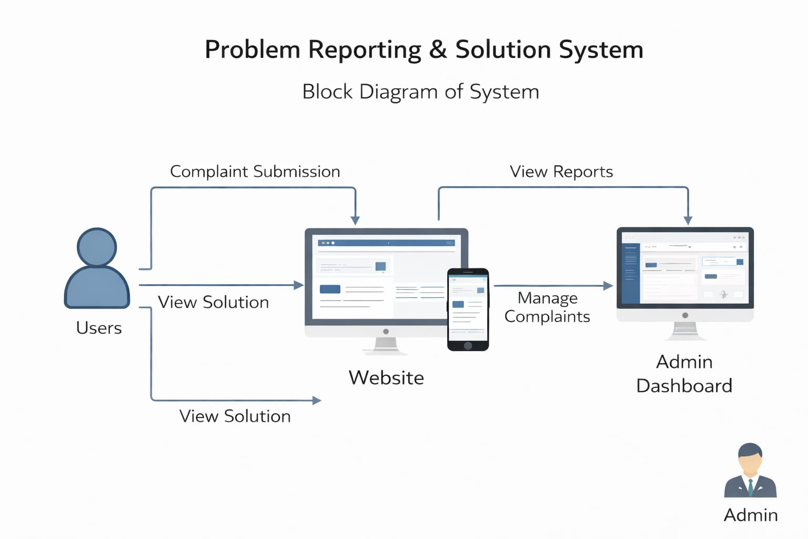
Figure 4.1 Block diagram of Civic Issue Reporting and Solution System

Figure 4.1 shows the proposed system diagram of Project Work Monitoring System, The diagram represents a Problem Reporting and Solution System where users interact with a website to submit their complaints and view solutions. Users send their issues through the complaint submission feature, which is processed by the system and forwarded to the admin dashboard. The admin reviews, manages, and updates the complaints, then provides appropriate solutions. These solutions are updated on the website, allowing users to view responses to their problems. The system ensures smooth communication between users and administrators by managing complaint data efficiently.
Input: The input in this system includes complaints and problem details submitted by users through the website. Users may also provide additional information such as their name, contact details, or other relevant data. Furthermore, the admin contributes input by updating complaint status, managing records, and adding solutions or responses to the submitted issues.
Output : The output of the system consists of solutions or responses provided to users based on their complaints. Users can view the status of their complaints, such as whether they are pending or resolved. Additionally, the system generates reports and summaries that are displayed on the admin dashboard, helping the admin monitor and manage all complaints efficiently.

CHAPTER 5
DETAILS OF DESIGNS, WORKING AND PROCESSES

System Flow Diagram:

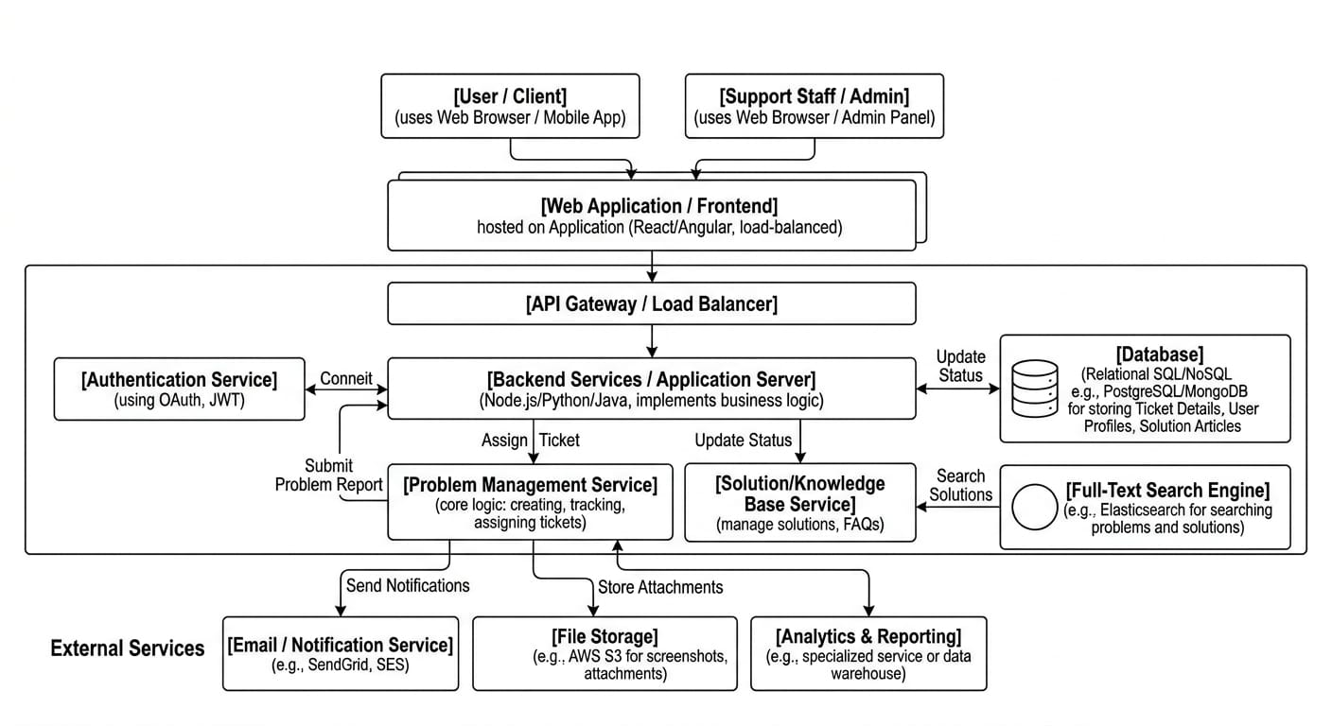

Figure 5.1 System diagram of Civic Issue Reporting and Solution System

Figure 5.1: The Problem Reporting and Solution System operates as a centralized digital ecosystem designed to streamline the lifecycle of a technical or service-related issue from submission to resolution. At its core, the system utilizes a Frontend interface for data entry, which communicates through an API Gateway to a robust Backend Service layer where business logic, such as ticket categorization and priority assignment, is executed. To ensure efficiency, the architecture incorporates a Primary Database for persistent record-keeping, a Full-Text Search Engine for rapid retrieval of existing solutions from a knowledge base, and External Services like cloud storage for attachments and automated notification engines for real-time status updates. This integrated approach ensures that every reported problem is securely authenticated, logically tracked, and systematically resolved through a data-driven workflow.

The Problem Reporting and Solution System is built on a scalable, service-oriented architecture designed to streamline the lifecycle of a technical issue from submission to resolution. At the user level, both Clients and Administrators interact with a load-balanced Web Frontend that communicates through an API Gateway to ensure secure and efficient request routing. The core logic is handled by specialized backend modules, including a Problem Management Service for ticket tracking and a Solution/Knowledge Base Service for managing FAQs, both of which rely on a Primary Database and a Full-Text Search Engine for high-speed data retrieval. To maintain optimal performance, the system offloads heavy tasks to external services, such as Cloud File Storage for attachments and automated Email/Notification Services for real-time status updates.

User and Administrator Module Flow:
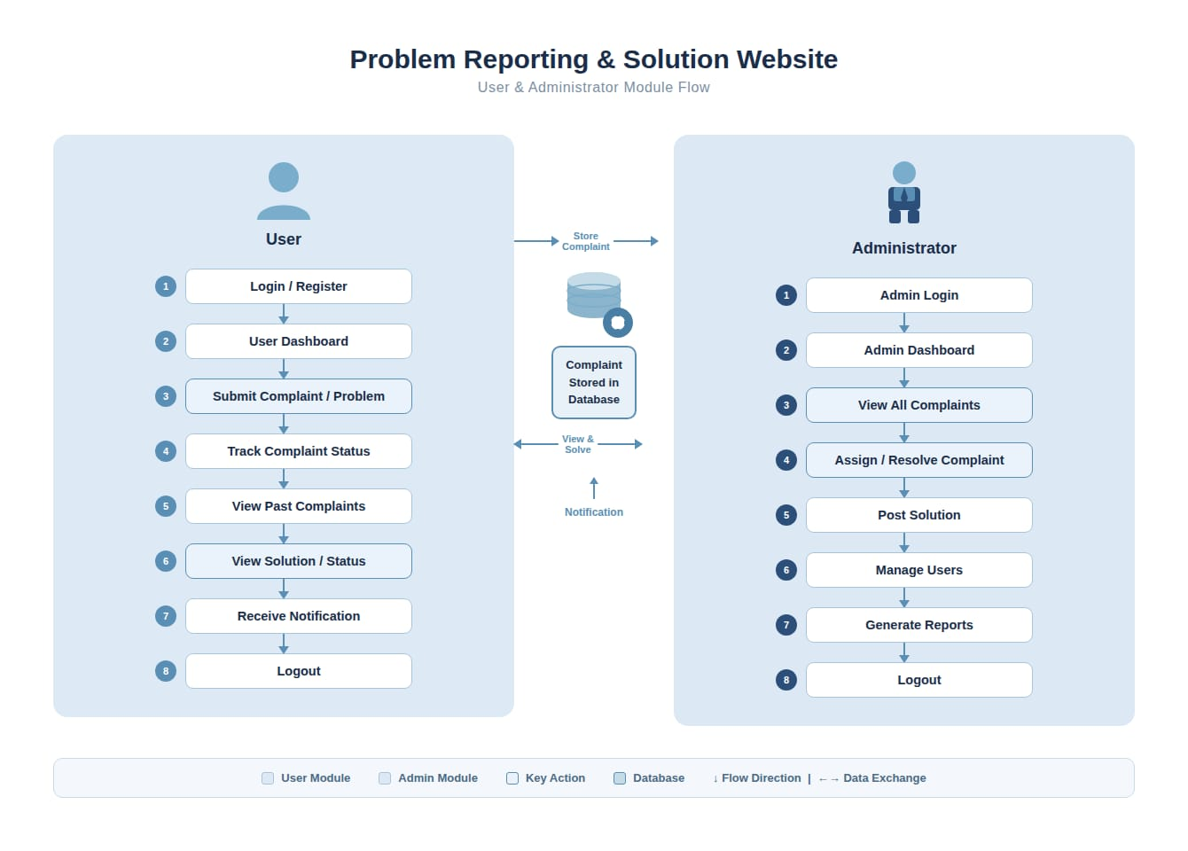
Figure 5.2 User and Administrator module flow

Figure 5.2: showThis diagram represents the workflow of a problem reporting and solution website, where both users and administrators interact through a central database. The process begins with the user logging in or registering, after which they access their dashboard to submit a complaint or report a problem. Once submitted, the complaint is stored in the database, allowing the user to track its status, view past complaints, and check the solution once it is provided. The system also sends notifications to keep the user updated about any progress or resolution, and finally, the user can log out after completing their activities.
User Module Flow:
The user begins by logging in or registering on the system and then accesses the user dashboard. From there, the user can submit a complaint or report a problem, which gets stored in the database. After submission, the user is able to track the complaint status, view past complaints, and check the solution or current progress. The system also sends notifications to keep the user updated about any changes or resolutions. Once all activities are completed, the user logs out of the system.

Administrator Module Flow:
The administrator starts by logging into the system and accessing the admin dashboard. From the dashboard, the admin can view all complaints submitted by users. The administrator is responsible for assigning or resolving complaints and posting appropriate solutions. In addition, the admin can manage user accounts and generate reports for analysis and monitoring purposes. After completing these tasks, the administrator logs out.

ER Diagram:
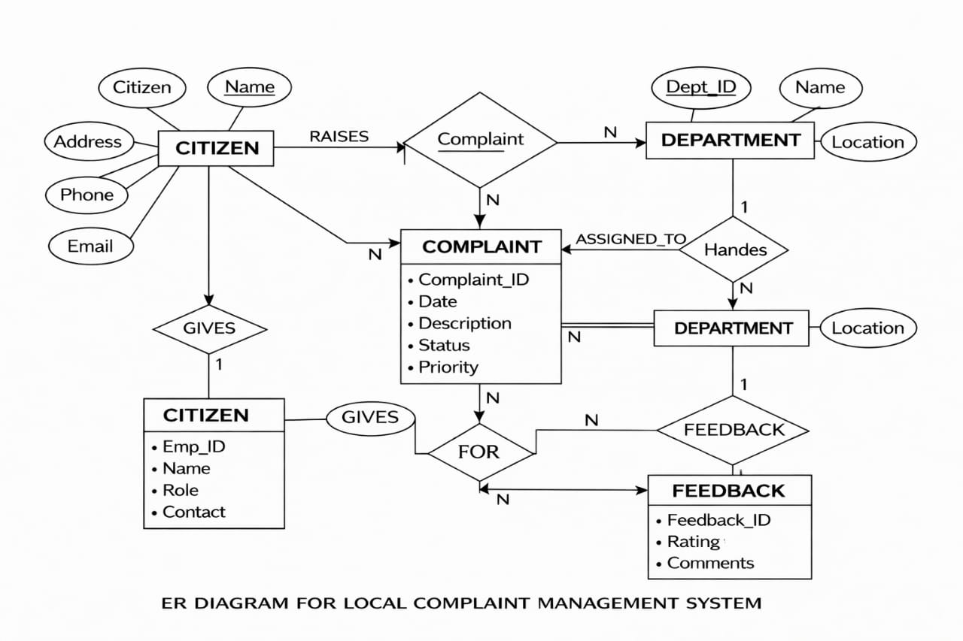

Figure 5.6 E-R diagram of Civic Issue Reporting and Solution System

Figure 5.6: This ER diagram represents a Local Complaint Management System, showing how different entities like citizen, complaint, department, and feedback are related to each other. The Citizen entity contains attributes such as name, address, phone, and email, and it plays a major role in the system by raising complaints. Each complaint is recorded in the Complaint entity, which includes details like complaint ID, date, description, status, and priority. A citizen can raise multiple complaints, indicating a one-to-many relationship between citizen and complaint.
The complaint is then associated with a Department, which is responsible for handling and resolving the issue. Each department has attributes like department ID, name, and location. One department can handle many complaints, establishing another one-to-many relationship. The diagram also shows that complaints are assigned to departments for resolution, ensuring proper management of issues.

CHAPTER 6

RESULT AND APPLICATION

Result
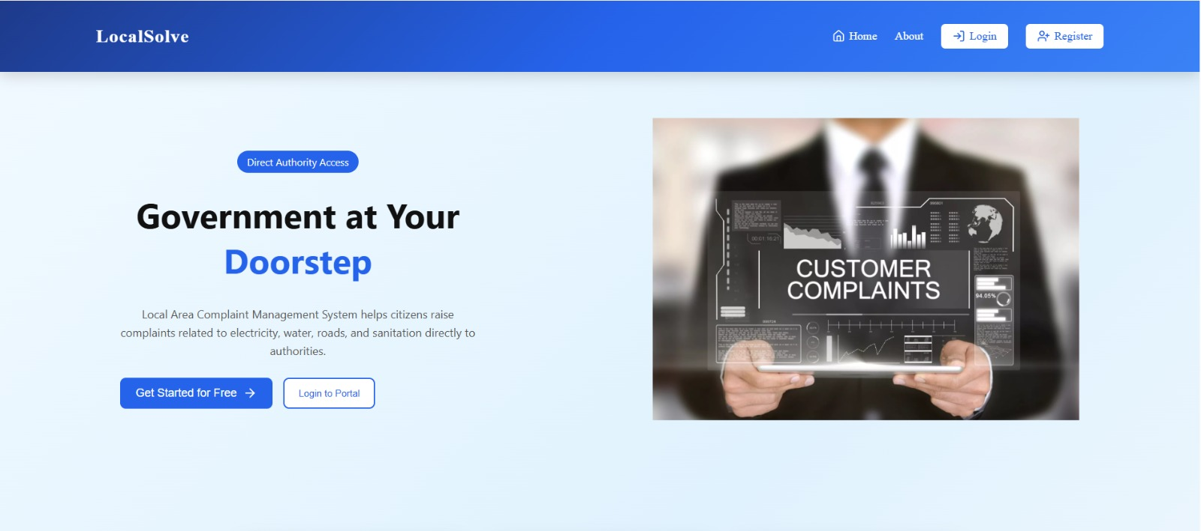
6.1.1 Home Page :

Figure 6.1 Home Page of Civic Issue Reporting and Solution System

Figure 6.1 The webpage shown is the homepage of a platform called “Local Solve,” which is designed to connect citizens directly with government authorities for resolving local civic issues. It acts as the entry point of the system and provides users with an overview of the platform’s purpose and key features.
The homepage highlights an important feature called “Direct Authority Access,” which emphasizes direct communication between users and concerned authorities without unnecessary delays. It promotes the concept of a “Local Area Complaint Management System,” where users can easily report issues related to essential public services such as electricity, water supply, road maintenance, garbage collection, and sanitation.
The interface includes a simple and user-friendly navigation bar with options like Home, About, Login, and Register, allowing users to quickly access different sections of the website. Additionally, prominent call-to-action buttons such as “Get Started for Free” and “Login to Portal” encourage users to register or log in and begin using the system immediately.

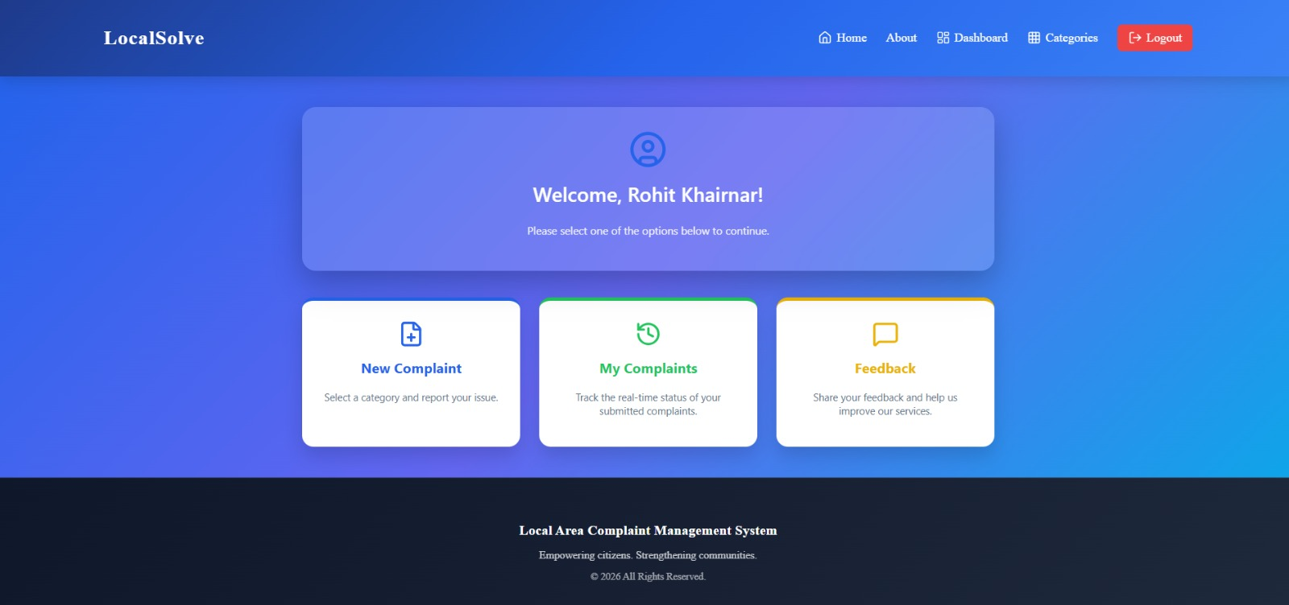
6.1.2 User Dashboard :

Figure 6.2 User Dashboard of Civic Issue Reporting and Solution System

Figure 6.2 This image shows the user dashboard page of the Local Solve platform after successful login. It welcomes the user (“Rohit Khairnar”) with a personalized greeting, creating a user-friendly and interactive experience. The dashboard is designed to provide quick and easy access to the main functionalities of the system.
The page includes three primary options:
- New Complaint: Allows users to submit new civic issues by providing necessary details such as title, description, location, and image.
- My Complaints: Enables users to view and track the status of previously submitted complaints, such as Pending, In Progress, or Resolved.
- Feedback: Provides a section where users can share their suggestions, opinions, or feedback to improve the system.
The top navigation bar consists of options like Home, About, Dashboard, Categories, and Logout, allowing users to easily navigate across different sections of the platform. The Categories section helps users select the type of issue (e.g., road, water, garbage, etc.), making complaint classification easier.
The overall design of the dashboard focuses on simplicity, clarity, and accessibility. It ensures that users can quickly perform important actions without confusion. The clean layout, proper alignment, and intuitive interface enhance the user experience and make the complaint management process efficient and user-friend

6.1.3 Admin Dashboard :
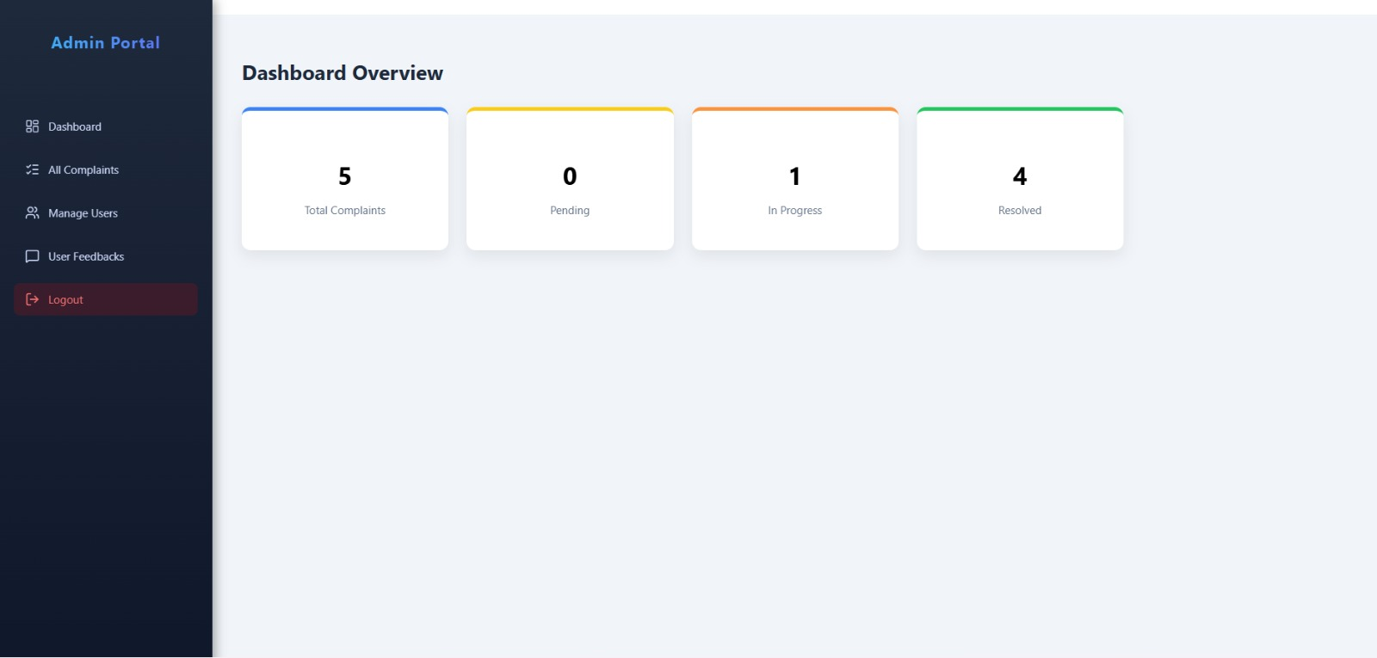

Figure 6.3 Admin Dashboard Page
Figure 6.3 This image shows the Admin Portal dashboard of the Local Solve system, which provides a centralized overview of complaint management activities. It serves as the main control panel for administrators to monitor and manage all system operations efficiently.
The dashboard displays important statistics in a clear and organized manner. It shows a total of 5 complaints, out of which 0 are pending, 1 is in progress, and 4 are resolved. These statistics give administrators a quick snapshot of system performance and help them understand the current status of reported issues. This visual summary enables faster decision-making and prioritization of tasks.
On the left sidebar, the system provides navigation options such as Dashboard, All Complaints, Manage Users, and User Feedbacks, along with a Logout option.
- All Complaints allows the admin to view and manage all reported issues in detail.
- Manage Users helps in handling user accounts and maintaining system control.
- User Feedbacks provides access to suggestions and opinions shared by users for system improvement.
The interface is designed with simplicity and clarity, ensuring that administrators can easily access all functionalities without confusion. The structured layout, combined with real-time data display, helps in effective monitoring and management of complaints.

6.1.4 Login
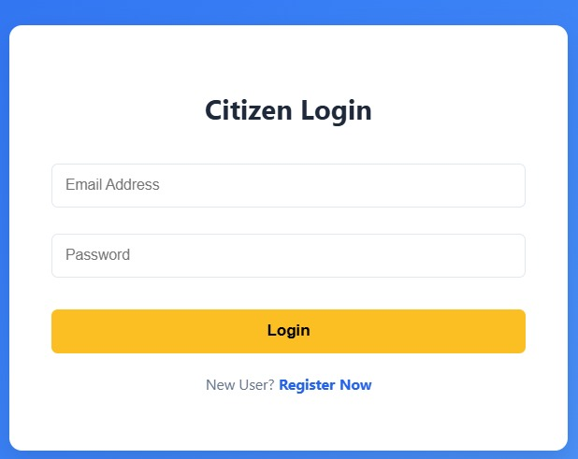
Figure 6.4 Login Page
Figure 6.4 The image shows the Citizen Login page of the Local Solve platform, which is designed to provide secure and easy access for registered users. This page acts as an entry point for citizens to access their personal dashboard and use the complaint management features of the system.
The login form includes input fields for Email Address and Password, where users are required to enter their registered credentials. A clearly visible “Login” button is provided to submit the entered details and authenticate the user. The system ensures that only valid users can log in, thereby maintaining security and preventing unauthorized access.
Below the login form, a “Register Now” link is available for new users who do not have an account. This option allows them to quickly navigate to the registration page and create a new account, making the platform accessible to all users.
The design of the login page is simple, clean, and user-friendly. It focuses on minimizing complexity so that users can log in quickly without confusion. Proper alignment, clear labels, and a responsive layout enhance usability across different devices.

6.1.4 Register :

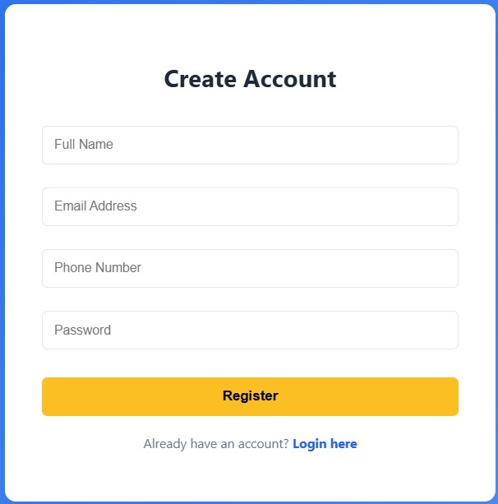

Figure 6.5 Register Page
Figure 6.5 The image represents the Citizen Registration page of the Local Solve platform, which allows new users to create an account and access the system. Although the displayed image appears visually distorted or glitched, it is intended to show the registration interface of the application.
The registration page typically includes input fields such as Full Name, Email Address, Password, and Confirm Password, which users must fill in to create a new account. A “Register” button is provided to submit the entered details and complete the registration process. The system validates user input to ensure that all required fields are filled correctly and securely.
In addition, the page may include a link such as “Already have an account? Login”, allowing existing users to navigate back to the login page easily.
Overall, the Registration page plays an important role in onboarding new users and enabling them to participate in reporting and tracking civic issues through the platform.

6.1.5 Sub Category
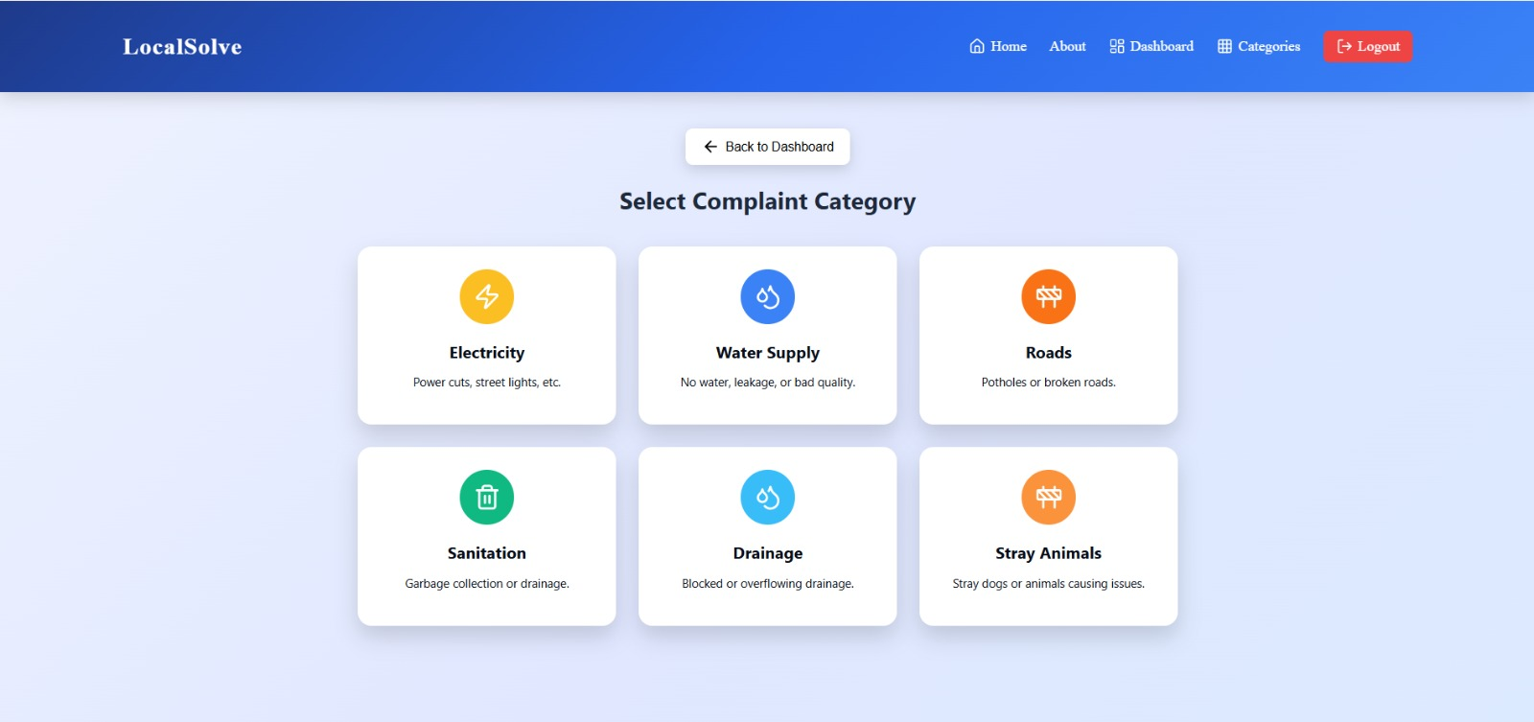
Figure 6.6 Complaint Manages Page
Figure 6.6 This image shows the Complaint Management page of the Local Solve platform, specifically the Select Complaint Category section. This page allows users to choose the type of issue they want to report, making the complaint submission process more organized and efficient.
The interface provides multiple categories such as electricity, water supply, roads, sanitation, drainage, and stray animals. These predefined categories help users quickly identify the nature of their problem and select the most appropriate option without confusion. Categorizing complaints also helps the system automatically route issues to the relevant authorities or departments.
By selecting the correct category, users ensure that their complaint is handled by the appropriate department, which improves response time and resolution efficiency. This structured approach reduces miscommunication and avoids delays in processing complaints.
Overall, this page plays a crucial role in streamlining the complaint registration process by ensuring proper classification and efficient handling of civic issues.

6.1.6 Complaint Manages
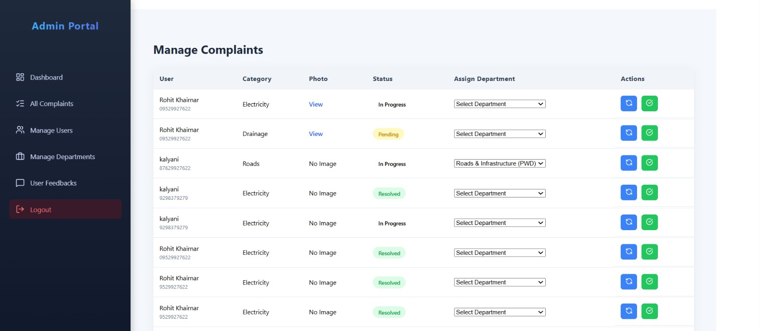
Figure 6.7 Complaint Manages Page

Figure 6.7: This image shows the Admin Portal – Manage Complaints section of the Local Solve platform. This page is designed to help administrators view, monitor, and manage all user complaints in a centralized interface.

The page displays detailed information for each complaint, including user name, complaint category, uploaded photo, current status, and assigned department. This comprehensive view allows administrators to quickly understand the nature of each issue and take appropriate action.

Administrators are provided with controls to assign complaints to specific departments, ensuring that each issue is handled by the relevant authority. They can also update the complaint status as Pending, In Progress, or Resolved, depending on the progress of the issue. These updates are reflected in the user dashboard, enabling transparency and keeping users informed about their complaint status.

The design of the page focuses on clarity, organization, and ease of use, enabling administrators to handle a large number of complaints without confusion. It improves workflow efficiency and ensures timely resolution of civic issues.

6.1.7 Complaint Status

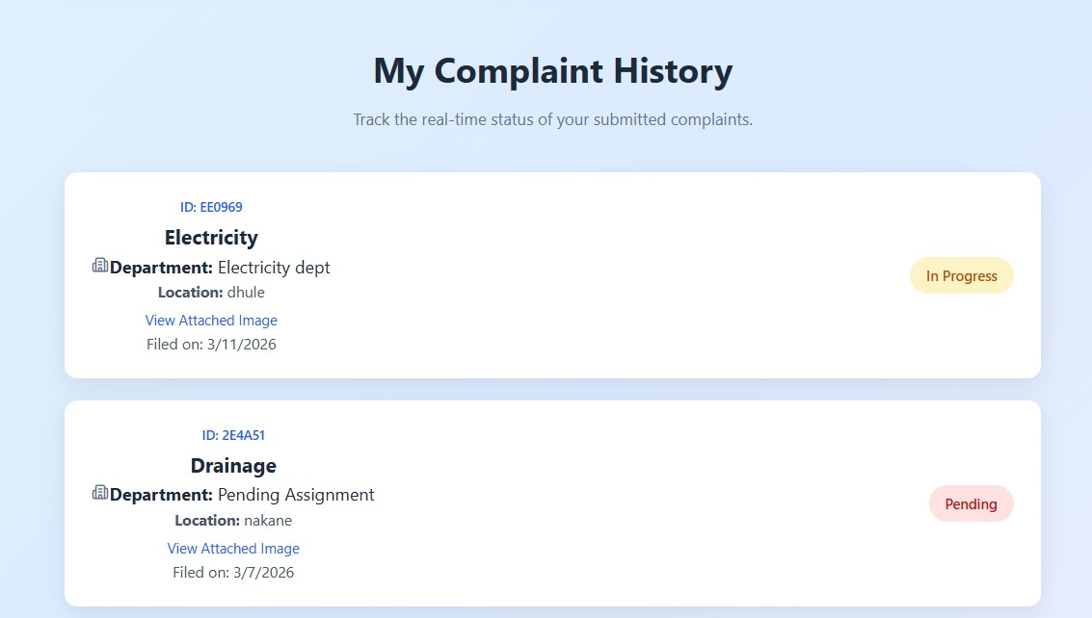
Figure 6.8 Complaint Status Page

Figure 6.7 This image shows the Complaint History page of the Local Solve platform, where users can view a complete record of all the complaints they have submitted. This page is designed to help users easily track and manage their previously reported issues.

The page displays important details for each complaint, including Complaint ID, Department, Location, and Filing Date. These details help users identify each complaint clearly and understand where and when it was reported. Additionally, the page shows the current status of each complaint, such as Pending, In Progress, or Resolved, allowing users to stay updated on the progress of their issues.

Users can also view attached images for each complaint, which provides visual confirmation of the reported issue. This feature enhances transparency and helps users verify that their complaint has been recorded correctly.

The layout of the page is structured and easy to understand, ensuring that users can quickly access all relevant information without confusion. It may also include options like viewing more details or filtering complaints based on status.

Application of Civic Issue Reporting and Solution System:

The Civic Issue Reporting and Solution System can be applied in various areas where efficient reporting and resolution of public problems are required. It provides a platform for citizens to submit complaints regarding local issues such as road damage, garbage collection, water leakage, drainage problems, and streetlight failures. At the same time, authorities and administrators can track, manage, and resolve these issues in a systematic manner. In urban and rural areas, citizens can easily report civic problems from their mobile or computer without visiting government offices. This helps in saving time and ensures faster communication between the public and authorities. The system also allows users to track the status of their complaints until they are resolved, increasing transparency and accountability. For municipal corporations and government departments, the system helps in organizing and prioritizing complaints based on urgency and location. Authorities can assign tasks to field workers, update the status of issues, and ensure timely resolution. This improves overall service efficiency and public satisfaction.

CHAPTER 7
TESTING AND DEFECT REPORT

7.1 INTRODUCTION
This chapter covers the testing activities performed for the Civic Issue Reporting and Solution System. Testing of this system is important because it acts as a platform for citizens to report local issues such as road damage, garbage problems, water leakage, streetlight failures, and other civic concerns. If any module fails or behaves incorrectly, the system may not function properly and complaints may not reach the concerned authorities.
The objective of this testing phase is to verify that all functionalities work correctly for all users, including citizens, authorities, and administrators. The system should allow users to register and log in successfully, report issues with proper details, upload images, track complaint status, and receive updates. Authorities should be able to view, manage, and update the status of reported issues efficiently. The system must also prevent unauthorized access and handle invalid inputs by validating all required fields.
Testing was carried out for both positive scenarios (successful login, issue reporting, image upload, status tracking, and complaint resolution updates) and negative scenarios (invalid login, missing details, incorrect inputs, duplicate complaints, and unauthorized access).
Testing was performed using the following tools:
• Selenium IDE: A record-and-playback tool used for quick testing of user interface scenarios.
• Selenium WebDriver: A scripting tool used for automated and repeatable test execution with proper validation
Out of scope for this chapter:
• Advanced security testing
• Performance and load testing
• Third-party integration testing

7.2 TEST PLAN
The test plan defines the objectives, scope, testing environment, tools, entry and exit criteria, and risk factors associated with testing of the Civic Issue Reporting and Solution System. This test plan is prepared to ensure a structured and systematic testing approach.
A proper test plan helps in maintaining consistency and accuracy during testing. It ensures that all modules such as Citizen, Authority, and Admin are tested thoroughly. The plan also helps in identifying defects early and improving the overall quality of the system.
Testing activities were designed to validate core functionalities like user registration and login, issue reporting, complaint tracking, image upload, authority response, and complaint resolution. The plan ensures that the system meets the required functional and non-functional requirements effectively.
Test Plan: (Civic Issue Reporting and Solution System)
Version: 1.0
Test Plan ID: TP CIVIC_01
Introduction:
The test plan describes the testing process for the Civic Issue Reporting and Solution System. The system allows citizens to register and report civic issues, authorities to review and update complaint status, and administrators to manage users and complaints. The system ensures a secure and correct flow from complaint submission to final resolution.
Test Items:
- Citizen Registration Module
- Login Module
- Issue Reporting Module
- Complaint Status Tracking Module
- Authority Response Module
- Admin Management Module
- Image Upload Module
- Database Storage Module
- Output Display Module

Features to be tested:
- Citizen registration and login
- Valid and invalid login checking
- Issue submission with required details
- Uploading issue images
- Complaint status tracking
- Authority updating issue status
- Admin managing complaints and users
- Data storage in database
- Validation of required fields
- Prevention of unauthorized access
Feature not to be Tested:
- Real-time GPS tracking of complaints
- Advanced security testing
- External API integration
- Advanced UI/UX design
- SMS or Email notification integration
Approach:
- Functional and non-functional testing will be performed
- Positive and negative rest case will be executed
- Manual testing and selenium automation will be used
- Boundary value and validation testing will be performed
Pass/Fall Criteria:
- All high-priority test cases must be pass successfully
- System should not have any critical or blocking defects.
- Expected results should match actual results for test.
- All major defect must be fixed

Failure Criteria:
- Incorrect output is displayed
- System crashes during execution
- Complaint is not saved or updated correctly
- Unauthorized user can access restricted pages
Suspension criteria & Resumption Requirement:
Suspension criteria:
- system crash
- Login system failure
- Complaint submission module not working
- Database connection error
Resumption:
- After fixing the issue and verifying the solution.
Test Deliverable:
- Test Plan document
- Test cases
- Defect Reports
- Test Result Reports
- Final Testing summary
Test Tasks:
- Prepare test cases
- Execute rest case
- Record results
- Identity defects
- fix bugs
Test Environment:
OS: Windows
Frontend: HTML, CSS, React
Backend: Node.js
Database: MongoDB
Responsibilities:
Developer: Develop and fix bugs.
Tester: Perform testing and report defects.
Staffing and Training:
Team member trained React.js, MongoDB Basic knowledge of testing technique required
Scheduling:
Project deadline:- 14 March 2026, 12:00PM
Risks:
- Complaint not reaching the correct authority
- Incorrect status updates
- Duplicate complaint submission
- Image upload failure
Approvals:
Project Guide, Team Member
• UI inconsistencies on different devices
• Dependency on internet and server availability

7.3 TEST CASES
Table 2 Test cases
Test Case ID | Objective | Input (Step) | Expected Output | Actual Output | Status
TC_001 | User Registration | Fill Registration Form | Registration successful | Registration successful | Pass
TC_002 | Login with invalid credentials | Enter wrong  Username/password | Login should be blocked with error message | User able to Login | Fail
TC_003 | User Login | Enter valid credentials | Login successful | Login successful | Pass
TC_004 | Report Issue | Enter issue details (title, description, location) and submit | Issue submitted successfully | Issue  submitted | Pass
TC_005 | Upload Image | Upload image while reporting issue | Image uploaded successfully | Image  uploaded | Pass
TC_006 | View Issues | Open issue list page | All reported issues displayed | Displayed | Pass
TC-007 | Track Issue Status | Check status of submitted issue | Status visible (Pending/In Progress/Resolved) | Status visible | Pass
TC-008 | Admin Login | Enter valid admin credentials | Admin login successful | Login  successful | Pass
TC-009 | Update Issue Status | Admin updates issue status | Status updated successfully | Updated | Fail
TC-010 | Reject Invalid Issue | Submit incomplete issue details | Error message should be shown | Error shown | Fail
TC-011 | Unauthorized Access | Try accessing admin panel without login | Access should be denied | Access granted | Fail
TC-012 | Missing Data Validation | Submit form without required fields | Validation error message | Error shown | Fail

7.4 DEFECT REPORT:-
The Issue Reporting and Management Module is a crucial part of the Civic Issue Reporting and Solution System. It allows citizens to report problems and enables authorities to manage and resolve them. This module ensures proper communication between users and authorities. Any issue in this module may affect the system workflow, making it essential to test and monitor it carefully.
Defect Report 1:-
Table 3 Defect Report (Problems Management Module)
Defect ID: | DR001
Project Name: | Civic Issue Reporting and Solution System
Product: | Web Application
Release Version: | v1.0
Module: | Problems Management Module
Detected Build Version: | v1.1
Summary: | Issue in reporting and status update process
Description: | After submitting a civic issue, the system does not behave as expected. The reported issue is not properly stored in the database or does not appear in the issue list. In some cases, even after the authority updates the issue status (e.g., In Progress or Resolved), the updated status is not visible to the user. This indicates a possible issue in data storage, synchronization, or frontend display logic.
Actual Result: | Issue not displayed properly and status updates not visible to users
Expected Result: | Issue should be stored correctly and displayed with updated status
Severity: | High (Affects core functionality of the system)
Priority: | High (Requires immediate fix)
Reported By: | Test Engineer
Status: | Open

7.5 TEST PLAN
The test plan defines the objectives, scope, testing environment, tools, entry and exit criteria, and risk factors associated with testing the Issue Reporting & Status Update Module of the Civic Issue Reporting and Solution System. This test plan is prepared following a structured format to ensure proper testing and quality assurance.
A structured test plan ensures that testing activities are systematic, consistent, and aligned with project quality goals. It also helps in identifying defects early and improving system reliability.
Test Plan: (Civic Issue Reporting and Solution System)
Version: 1.0
Test Plan ID: TP_ISSUE_01
- Introduction
This test plan verifies that the Issue Reporting & Status Update Module works correctly. It ensures that users can report issues successfully and that authorities can update the issue status properly. It also checks system behavior for invalid conditions and ensures proper workflow after submission.

- Test Items
• Issue status update functionality
• Issue reporting functionality
• Issue display in user dashboard
• Data storage and retrieval
• Error handling and validation
- Features to be Tested
• Submit issue with valid details
• Upload image with issue
• Update issue status (Pending/In Progress/Resolved)
• Display issue to users
• Data synchronization between frontend and backend
- Features Not to be Tested
• Login module
• External API integration
• Notification services
• Advanced analytics
- Approach
• Functional testing will be performed
• Positive and negative test cases will be executed
• Manual testing and Selenium automation will be used
• UI and workflow validation testing will be included
• API testing using Postman
- Pass / Fail Criteria
• All critical and high-priority test cases must pass
• Issues should be submitted and displayed correctly
• Status updates should reflect properly
- Suspension Criteria and Resumption Requirements
Suspension:
- System crash
- Issue submission not working
Resumption:
- After fixing issues and verifying results
- Test Deliverables
  - Test plan document
  - Test cases document
  - Defect report
  - Test summary report

- Test Tasks
• Prepare test plan and test cases
• Execute test cases
• Identify and report defects
• Retest after bug fixing
• Prepare final test report
- Test Environment
  - Operating System: Windows 11
  - Browser: Google Chrome, Microsoft Edge
  - Frontend: React (localhost)
  - Backend: Node.js + Express.js
  - Database: MongoDB
  - Server: Localhost / Test Server
  - Tools: Selenium IDE, Postman
- Responsibilities
  - QA Lead: Review artifacts
  - Test Engineer: Execute tests and log defects
  - Developer: Fix defects
  - Project Manager: Approve release
- Staffing and Training
Knowledge of approval workflow, testing techniques, and tools is required.
- Scheduling
Project deadline: 20 March 2026, 12:00 PM
- Risks
  - Invalid test data
  - Browser compatibility issues
  - Server downtime
  - Security vulnerabilities
15. Approvals
Project Guide, Team Members
Table 4 Test Cases for your defect (Issue Reporting & Status Update Module)
Test Case ID | Objective | Input (Step) | Expected Output | Actual Output | Status
TC_001 | Issue submission | Fill issue form with  valid details and submit | Issue should be submitted successfully | Issue submitted successfully | Pass
TC_002 | Issue display after submission | Submit issue and check dashboard | Issue should be visible in list | Issue not displayed | Pass
TC_003 | Status update by authority | Authority updates issue status | Status should be updated (In Progress/Resolved) | Status not updated | Pass
TC_004 | Data storage validation | Submit issue and check database | Issue should be stored in database | Data stored correctly | Pass
TC_005 | Real-time status reflection | Update status and refresh page | Updated status should be visible | Status visible  After refresh | Pass

7.6 DEFECT REPORT:-
The Image Upload Module is an important part of the Civic Issue Reporting and Solution System. It allows users to upload images while reporting civic issues, which helps authorities understand the problem more clearly. Proper image upload improves issue clarity and resolution speed. However, if the image upload functionality fails, issues may be reported without proper visual proof, affecting decision-making and system effectiveness. Therefore, this module must be tested carefully.
Defect Report 2:-

Table 5 Defect Report (Image Upload Module)
Defect ID: | DR002
Project Name: | Civic Issue Reporting and Solution System
Product: | Web Application
Release Version: | v1.0
Module: | Image Upload Module
Detected Build Version: | v1.1
Summary: | Image upload failure in issue reporting
Description: | While reporting a civic issue, the image upload functionality does not work as expected. When the user selects and uploads an image file, the system either fails to store the image in the database or does not display it on the issue details page after submission. In some cases, the file path is not saved correctly or the image is not uploaded to the server. This results in issues being displayed without images.
Actual Result: | Image is not uploaded or not displayed with the issue
Expected Result: | Image should be uploaded successfully and displayed with the issue
Severity: | Medium (Affects issue clarity and user experience)
Priority: | High (Needs to be fixed)
Reported By: | Test Engineer
Status: | Open

7.7 TEST PLAN
The test plan defines the objectives, scope, testing environment, tools, entry and exit criteria, and risk factors associated with testing the Image Upload Module of the Civic Issue Reporting and Solution System. This test plan is prepared to ensure proper testing and quality assurance. A structured test plan ensures that testing activities are systematic, consistent, and aligned with project quality goals. It also helps in identifying defects early and improving system reliability.
Test Plan: (Civic Issue Reporting and Solution System)
Version: 1.0
Test Plan ID: TP_ IMAGE_02
- Introduction
This test plan verifies that the Image Upload Module works correctly. It ensures that users can upload images successfully while reporting issues and that images are stored and displayed properly. It also checks system behavior for invalid file inputs.

- Test Items
• Image upload functionality
• File storage and retrieval
• Image display in issue details
• File validation (size/type)
• Error handling
- Features to be Tested
• Upload image with valid format (JPG, PNG)
• Display uploaded image with issue
• Store image path in database
• Handle large file uploads
• Data synchronization
- Features Not to be Tested
• Login module
• Issue tracking module
• Notification system
• External API integration
- Approach
• Functional testing will be performed
• Positive and negative test cases will be executed
• Manual testing and Selenium automation will be used
• UI and workflow validation testing will be included
• API testing using Postman
- Pass / Fail Criteria
• All critical and high-priority test cases must pass
• Images should upload and display correctly
• Invalid files should be rejected
- Suspension Criteria and Resumption Requirements
• Testing will be suspended if critical defects are found
• Testing will resume after fixing the issues
- Test Deliverables
  - Test plan document
  - Test cases document
  - Defect report
  - Test summary report
- Test Tasks
• Prepare test plan and test cases
• Execute test cases
• Identify and report defects
• Retest after bug fixing
• Prepare final test report
- Test Environment
  - Operating System: Windows 11
  - Browser: Google Chrome, Microsoft Edge
  - Frontend: React (localhost)
  - Backend: Node.js + Express.js
  - Database: MongoDB
  - Server: Localhost / Test Server
  - Tools: Selenium IDE, Postman
  - Network: Internet connection

- Responsibilities
  - QA Lead: Review artifacts
  - Test Engineer: Execute tests and log defects
  - Developer: Fix defects
  - Project Manager: Approve release
- Staffing and Training
Knowledge of product management workflow, file upload handling, and testing tools is required.
- Scheduling
Project deadline: 20 March 2026, 12:00 PM
- Risks
• File upload failure issues
• Data storage errors
15. Approvals
Project Guide, Team Members
Table 5 Test Cases for your defect (Image Upload Module)
Test Case ID | Objective | Input (Step) | Expected Output | Actual Output | Status
TC_001 | Upload image with valid file | Select valid image (JPG/PNG) and submit | Image should upload successfully | Image uploaded successfully | Fail
TC_002 | Display uploaded image | Upload image and view issue details | Image should be visible with issue | Image not displayed | Fail
TC_003 | Upload invalid file format | Upload non-image file (PDF/TXT) | System should show error message | Error message displayed | Pass
TC_004 | Large file upload | Upload large size image | System should restrict or handle file properly | File not uploaded | Fail
TC_005 | Image path storage | Upload image and check database | Image path should be stored correctly | Path stored correctly | Pass
TC_006 | Refresh after upload | Upload image and refresh page | Image should still be visible | Image missing after refresh | Fail

CHAPTER 8

CONCLUSION AND FUTURE SCOPE

Conclusion:

The Problem Reporting and Solution Website (Project Work Monitoring System) has been successfully developed to provide a simple and efficient platform for users to report, track, and resolve problems. It reduces manual work and improves communication between users and administrators by offering features like problem submission, status tracking, and solution updates. The system ensures transparency, faster issue resolution, and better management of reported problems through its structured modules. Overall, the project meets its objectives and can be further improved by adding features such as mobile support, real-time notifications, and enhanced system performance.

Future Scope:

In the future, the Problem Reporting and Solution Website can be further enhanced by adding advanced features such as a mobile application for easy access, real-time notifications for status updates, and integration with email or SMS services.
The system can also include AI-based problem categorization, data analytics for better decision-making, and improved security features. Additionally, expanding the system to support multiple organizations and adding multilingual support can increase its usability and effectiveness. Reference and Bibliography.

CHAPTER 9

REFERENCE AND BIBLIOGRAPHY

Reference:

Books

- The Mythical Man-Month: Essays on Software Engineering – The Mythical Man‑Month

Websites

- https://ijrpr.com/uploads/V5ISSUE5/IJRPR28868.pdf
- https://www.ijtsrd.com/papers/ijtsrd21370.pdf
- https://aiktc.ndl.gov.in/items/a3f79aa9-f571-4b1f-b95c-33f04f155094

Bibliography:
- Pressman, R. S. – Software Engineering: A Practitioner’s Approach, McGraw-Hill.
- Sommerville, Ian – Software Engineering, Pearson Education.

